FAITH & REASON HONORS PROGRAM
CLASS OF 2019

Implications of Catholic Social Teaching for Capitalism
Caroline Accurso

“Implications of Catholic Social Teaching for Capitalism”

“Economics exist for man, and not man for economics.” – Nicholas Berdyaev

Abstract:

In this paper, we examine Catholic social teaching as put forth in various papal encyclicals to determine its economic implications. We then analyze various Catholic responses to the challenges put forth by the popes: the English distributist movement, the Catholic Worker movement in the United States, and Monsignor John A. Ryan’s ideas of distributive justice.
Finally, taking inspiration from these sources and keeping in mind basic economic principles, we discuss practical policies that can be put into place to reform our current economic system that it may promote greater equality, efficiency, and justice.

Introduction:

Many people in our world today are growing concerned with traditional capitalism, noting ill-effects of the system such as lack of respect for the environment and an increase in income inequality. Global economic well-being, traditionally measured by national income as well as by level of capabilities, grew during the second half of the twentieth century to an extent and with a speed never before experienced in the history of mankind. But the inequalities within and between various countries have grown significantly. For instance, in the United States by 2007, the year before the financial crisis, the top 0.1 percent of America’s households had an income that was 220 times larger than the average of the bottom 90 percent (Stiglitz). While more advanced countries, as well as many developing ones, have seen their income grow considerably, other countries and groups have in fact been excluded from the overall improvement of the global economy and their situation has even worsened. The United Nations’ 2016 Human Development Report describes the resulting inequality: “Some 46 percent of the

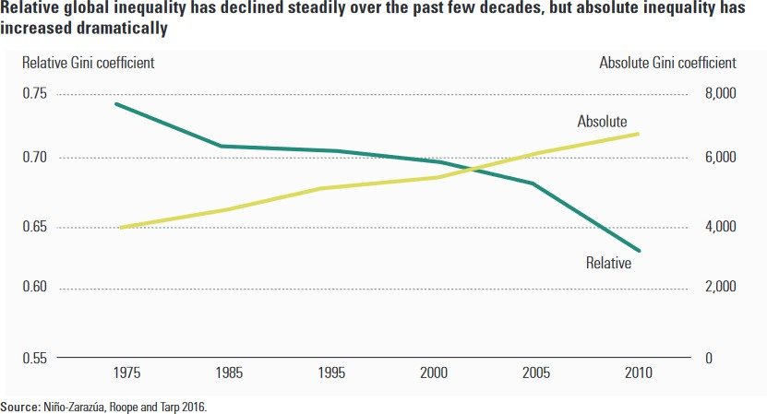total increase in income between 1988 and 2011
Figure 1: Recent trends in absolute and relative inequality
went to the wealthiest 10 percent. Since 2000, 50 percent of the increase in
global wealth benefited only the wealthiest 1 percent of the world’s population. Conversely, the poorest 50 percent of the world’s population received only 1 percent of the increase” (UNDP 31). As a result, although global relative inequality (calculated by dividing the amount that richer members of society earn by the amount that poorer members of society earn) has decreased due to rapid development in such countries as China and India, absolute inequality (calculated by subtracting the amount that poorer members of society earn from the amount that richer members of society earn) has increased steadily, as seen in Figure 1 above.
To achieve free and stable markets and a fair distribution of world wealth, people advocate various methods of reform. Some look to more socialist economic systems as a solution, while others maintain that the market will correct itself in time. Others, such as Ray Dalio, a prominent American businessman who claimed that “the American Dream has been lost” (2019) have declared that capitalism needs to be reformed. There are many and fundamental disagreements over how we, on the national level as well as on the global level, can best promote justice for our fellow human beings and the world that we live in – in short, for all of God’s creation. In seeking to solve such dilemmas, it can be useful to evaluate Catholic social

teaching carefully in conjunction with basic economic principles as a guide to inform us as to what we can do to create economic systems that are both just and economically sound.
To begin, we describe the basic tenets of Catholic social teaching and then connect them with basic economic principles. The principles of Catholic social teaching have been put forth and described in numerous papal encyclicals, notably Pope Leo XIII’s 1891 encyclical Rerum Novarum, Pope Pius XI’s 1931 encyclical Quadregesimo Anno, Pope John XXIII’s 1961 encyclical Mater et Magistra, and Pope John Paul II’s 1991 encyclical Centesimus Annus.
Rerum Novarum, or “Rights and Duties of Capital and Labor” – written during a time of widespread social upheaval and inequality, with the Gilded Age in the United States and the rise of Marxism and other workers’ movements – was the first papal encyclical to establish the Church’s position on social issues. Later encyclicals reinforced and clarified the positions outlined in Rerum Novarum as needed with the world’s changing social conditions.

Principles of Catholic Social Teaching:

As summarized by William J. Byron in his 1998 article “The 10 Building Blocks of Catholic Social Teaching”, these encyclicals promote ten basic principles that inform Catholic
teaching on social issues: the principle of human dignity, the principle of respect for human life, the principle of association, the principle of participation, the principle of preferential protection for the poor and vulnerable, the principle of solidarity, the principle of stewardship, the principle of subsidiarity, the principle of human equality, and the principle of the common good. These ideas are rooted in Christian anthropology, which is the Christian understanding of the human person and of society itself. Especially important in the informing of Catholic social teaching is the sanctity of the human person and all of God’s creation and our responsibility to care for them. These ideas, critical for nations’ well-being, will be elaborated in the following sections.

What implications do these principles have for the economy to function well? First, the principles of human dignity and of respect for human life imply that workers must be treated fairly and with justice, in a way that safeguards their dignity and promotes, rather than harms, their health and well-being. As Pope John Paul II wrote in Mater et Magistra, “Every effort must be made to ensure that the enterprise is indeed a true human community, concerned about the needs, the activities and the standing of each of its members” (91). A Catholic moral perspective demands that people always be treated as ends in and of themselves, rather than simply as means to ends.
Based on a similar view of the human person, the principle of association promotes the dignity of the human family and asserts the right of people to join together in institutions that promote the common good. Indeed, Rerum Novarum and Quadragesimo Anno specifically assert the rights of workers to form unions and syndicates. As Pope Leo XIII argues, “[T]o enter into a ‘society’ of this kind is the natural right of man; and the State has for its office to protect natural rights, not to destroy them; and, if it forbid its citizens to form associations, it contradicts the very principle of its own existence, for both they and it exist in virtue of the like principle, namely, the natural tendency of man to dwell in society” (Rerum Novarum 51). Leo asserts that since people naturally form societies, it goes against the dignity and freedom of the human person to outlaw the formation of labor unions. As this was the case in many countries at the time, including the United States, advocating the legality of labor unions was truly a radical stance to take. Leo, however, goes on to note that it is certainly permissible to outlaw the formation of societies of dangerous or evil purpose.
The principle of participation expands upon the principle of association to assert that all humans have the right to full participation in the economic system: everyone has the right to

work, to a living wage, to private property, and to form labor unions. Rerum Novarum noted that to work to support oneself is both the right and the duty of the human person: in Genesis 3:19 God says, “By the sweat of your brow you shall eat bread.” Leo argues, “The preservation of life is the bounden duty of one and all, and to be wanting therein is a crime. It necessarily follows that each one has a natural right to procure what is required in order to live, and the poor can procure that in no other way than by what they can earn through their work” (44).
According to the Catholic perspective, since all life is a gift from God, it must be taken care of. Therefore, those who are able to work should be allowed to do so and should be paid a wage that enables them to support themselves and their families.
The additional assertion of the right to private property is, again, based on the Catholic view of the human person. Rerum Novarum argues,
“And on this very account – that man alone among the animal creation is endowed with reason – it must be within his right to possess things not merely for temporary and momentary use … but to have and to hold them in stable and permanent possession; he must have not only things that perish in the use, but those also which, though they have been reduced into use, continue for
further use in after time … [M]an not only should possess the fruits of the earth, but also the very soil, inasmuch as from the produce of the earth he has to lay by provision for the future.”
(6-7)

This encyclical was written at a time when many people were farmers and supported themselves by working the land. Thus, since the ownership of private property that one could farm was such a key way for people to obtain the means they needed to survive, Leo argues that this ownership must be spread to as many as possible. In later encyclicals, in keeping with the development of modern economies, the popes acknowledged other forms of private property besides land ownership, including capital and intellectual property. However, they insisted that the right to private property implies that one must use one’s property to the benefit of others.

The principle of preferential protection for the poor and vulnerable means that we as a society have a duty to the weaker and less fortunate in our midst – to make sure that they are not taken advantage of, that they are treated with dignity, and that their basic needs are met. Rerum Novarum specifically asserts this in the following passage: “Still, when there is question of defending the rights of individuals, the poor and badly off have a claim to especial consideration. The richer class have many ways of shielding themselves … whereas the mass of the poor have no resources of their own to fall back upon …” (37). Thus, they will need more help and support from outside sources. One is reminded of the words of Jesus in Matthew 25:40: “[W] hatever you did for one of these least brothers of mine, you did for me.” Dorothy Day and Peter Maurin, founders of the Catholic Worker Movement, used to say that one met Christ in the poor.
The principle of solidarity reminds us that we are all part of the universal human family and that we must work not just for the well-being of the members of our communities and nations, but also for the well-being of the people of other nations with whom we interact. As Pope John XXIII wrote in Mater et Magistra, “The solidarity which binds all men together as members of a common family makes it impossible for wealthy nations to look with indifference upon the hunger, misery and poverty of other nations whose citizens are unable to enjoy even
elementary human rights” (157). This, again, is based on the principle of an absolute and intrinsic human dignity common to all which implies our responsibility to care for all others. Philosophically considering the consequences of not showing solidarity and care for others, as John Crosby does in his essay “Scheler on Solidarity of Persons”, we see that,
“My failure to love the other leaves him with one less reason for loving, for it deprives him of the call to requite my love. But in having one less reason for loving, the other grows that much less in the power to love, for the power to love grows by performing acts of love … When the other turns to all those who are his others, he

turns to them with less power to love than he would have had if I had loved as I should have loved.”
(Personalist Papers 77)

Thus, we can see that choosing to care or not care for others may have far-reaching consequences beyond the direct impact of our actions, and we must keep this in mind when pondering how to treat others.
Beyond caring for all human beings, we must additionally care for the environment and use resources in a sustainable manner, as implied by the principle of stewardship. This idea is founded not only on the belief that the world was created by God and declared “good” and must be valued and protected for this reason, but also in part on the assertion in Christian theology of the sacramentality of the elements of the material world – we can and must come to know God by means of the natural world. As Alexander Schmemann writes in his book For the Life of the World: Sacraments and Orthodoxy,
“We need water and oil, bread and wine in order to be in communion with God and to know Him … it is this communion with God by means of ‘matter’ that reveals the true meaning of ‘matter,’ i.e., of the world itself … Thus the term ‘sacramental’ means that for the world to be means of worship and means of grace is not accidental, but the revelation of its meaning, the restoration of its essence, the fulfillment of its destiny.”
(121)

Since such is the nature of the world, it can be seen that we have a critical duty to care for it.

The principle of subsidiarity means that whenever a function can be performed efficiently at a lower level of institution, it should be performed at that lower level rather than at a higher one. As Pope Pius XI writes in Quadragesimo Anno,
“Just as it is gravely wrong to take from individuals what they can accomplish by their own initiative and industry and give it to the community, so also it is an injustice and at the same time a grave evil and disturbance of right order to assign to a greater and higher association what lesser and subordinate organizations can do. For

every social activity ought of its very nature to furnish help to the members of the body social, and never destroy and absorb them.”
(79)

Under the principle of subsidiarity, it is encouraged that solutions to problems be generated closer to the problems themselves and to the people affected. This way, it is more personal and does not involve quite as much bureaucracy.
The principle of human equality clearly insists on the equal dignity of each person and the need for respect of all people’s basic human rights. Related to many of the principles stated above, this principle is based on the belief that all humans are made in God’s image and likeness and therefore equal in terms of worthiness of respect. It is important to note, that this principle must not be seen as conflicting with the principle of preferential protection for the poor and vulnerable. That principle does not imply that the poor and vulnerable are worth more than the rich and powerful but rather that they will require more help and support from government and society due to a lack of resources of their own.
Finally, the principle of the common good means that we have a duty to create institutions that will promote the well-being of all in ways consistent with their dignity. This is related to the previous principles of human dignity and respect for human life, as well as in the principle of solidarity, as we each have a responsibility for the well-being of those around us. As Pope John Paul II writes in Centesimus Annus,
“Man receives from God his essential dignity and with it the capacity to transcend every social order so as to move towards truth and goodness. But he is also conditioned by the social structure in which he lives, by the education he has received and by his environment. These elements can either help or hinder his living in accordance with the truth. The decisions which create a human environment can give rise to specific structures of sin which impede the full realization of those who are in any way oppressed by them.”
(38)

Our duty towards others implies that we must ensure an environment in which they can “be who they are and be that well,” in the words of St. Francis de Sales – to live out their vocations and fulfill the specific plans that God has in mind for their lives.
Clearly, the ten principles of Catholic social teaching outlined above have many implications for the economy, some of which have already been mentioned. Many writers have attempted to defend various economic systems, claiming their consistence with the principles of Catholic social teaching outlined above – for example, “Confessions of a Catholic Convert to Capitalism” by Arthur C. Brooks; “Yes, Democratic Socialism is Compatible with Catholic Social Teaching” by Brianne Jacobs; and “A Libertarian Case for the Common Good” by Stephanie Slade. Some, beginning with the English writers G. K. Chesterton (May 29, 1874 –
June 14, 1936) and Hilaire Belloc (July 27, 1870 – July 16, 1953), have looked for alternatives to the two traditional options, capitalism and socialism, in the form of distributism: a proposed economic system in which everything would be organized at the local level as much as possible and the ownership of private property would be spread as widely as possible. The Freiburg school of thought also emphasized many principles of Catholic social teaching:
“Ordoliberal thinkers have the firm conviction, that a free economic (and political) system needs a constitutional order, the rules of which hold the competitors in a market within certain limits, thus guaranteeing the maintenance of a free and fair competition. They developed a personalistic and humanistic outline of a socio-economic order, at the centre of which stands the human person and his or her inalienable rights, including the social rights. It emphasizes both the personal responsibility of each
individual and solidarity in the social community”
(Melé and Schlag 7)

So which one is it? What practical policies or economic systems could be put into place to implement the principles of Catholic social teaching in our societies and institutions? And what

do basic economic principles have to say about how the principles of Catholic social teaching should be applied to promote more equality, efficiency and justice?

Socialism:

At first glance, socialist systems may seem like a very tempting option and one likely to be successful in obtaining justice for all and respect for the rights of workers and the poor. If property were held in common, there would be no inequality on the basis of varying levels of possessions. The hope of the socialists is that this would then promote more peace and prosperity for the nation. While this is certainly an aspiration shared by all, and perhaps a socialist system would in fact help in creating a more just society, it remains true that a socialist system in the traditional sense would deny certain basic human freedoms to obtain its goal of providing material advantage to all. In addition, in reality it could not achieve what theory suggested. Catholic social teaching does not reject many of the aspirations of socialism, but it does reject the underlying view of society held by socialism: that the most important goal of life is to obtain material goods and that all else is subject to this. Pius XI summarized this criticism in Quadragesimo Anno:
“Socialism … affirms that human association has been instituted for the sake of material advantage alone … Indeed, possession of the greatest possible supply of things that serve the advantages of this life is considered of such great importance that the higher goods of man, liberty not excepted, must take a secondary place and even be sacrificed to the demands of the most efficient production of goods.”
(118-119)

In socialism, the good of the human person is subjected to the good of society, to its detriment.

Equally, however, can it be said that traditional unregulated capitalism that advocates the gaining of maximum profit using any means available holds the same flawed assumption that the most important goal is the procurement of material goods. For this reason, most Catholic

responses to the challenges issued by Popes Leo XIII, Pius XI, John XXIII, John Paul II, and others have emphasized the need for a spiritual reform as well as an economic and financial one. In “Toward Reforming the International Financial and Monetary Systems in the Context of Global Public Authority”, the Pontifical Council for Justice and Peace declared, “Pope Benedict XVI precisely identified the roots of a crisis that is not only economic and financial but above all moral in nature. In fact, as the Pontiff notes, to function correctly, the economy needs ethics; and not just of any kind but one that is people-centered.” Certainly, it can be seen that in our fallen state, any economic system without ethics will be imperfect and will suffer from human temptations to greed.

Catholic Responses to Social Encyclicals:

One early Catholic response to the challenges presented by Pope Leo XIII in Rerum Novarum was made by Monsignor John A. Ryan. Born on May 25, 1869 in Minnesota, he was ordained a priest in 1898. In 1906, he was granted a Doctorate of Sacred Theology, with his dissertation A Living Wage. Much of his life revolved around teaching – he was an associate professor of political science at the Catholic University of America in Washington, D.C. from 1915 to 1939. During this time, he also taught economics at Trinity College in that same city. He sought economic policies and principles based on ethics, natural law theory, and Catholic social teaching. Many of his ideas were incorporated into President Franklin D. Roosevelt’s New Deal intended to provide relief during the Great Depression.
Although some later Catholics criticized Ryan for seemingly basing his principles solely in reason and de-emphasizing the importance of faith and morality, this is not at all true. In fact, at the end of his book Distributive Justice, Ryan specifically writes, “Neither just distribution, nor increased production, nor both combined, will insure a stable and satisfactory social order

without a considerable change in human hearts and ideals … For the adoption and pursuit of these ideals the most necessary requisite is a revival of genuine religion” (432-433). Indeed, Ryan’s work was a specific response to the challenges presented by Rerum Novarum, drawing on natural law theory to develop and promote policies that would be in keeping with the principles expressed in this encyclical.
Ryan wrote of distributive justice, a topic also mentioned by Leo XIII: “Among the many and grave duties of rulers who would do their best for the people, the first and chief is to act with strict justice – with that justice which is called distributive – toward each and every class alike” (Rerum Novarum 33). As Ryan described it, “Distributive justice is primarily a problem of
incomes rather than of possessions … Its province is not the distribution of all the goods of the country among all the people of the country, but only the distribution of the products of industry among the classes that have taken part in the making of these products” (Distributive Justice
- Ryan further distinguishes four classes having to do with production: “These classes are designated as landowners, capitalists, undertakers or business men, and labourers or wage earners” (xiii). Ryan’s work Distributive Justice deals with the applications of economics and moral principles to the problem of ensuring distributive justice. We shall return to a discussion of some of his proposals and their moral and economic justifications later in this paper.
Another Catholic response to the challenges of the papal encyclicals took shape in the form of the English distributist movement. Although individual distributists held slightly different versions of this philosophy, there were a few core elements upon which all agreed. Led by G. K. Chesterton and Hilaire Belloc, the distributists advocated the spread of private ownership to as many as possible. They supported societies based on small farms and artisans’ businesses, with a focus on family and the land. They also supported the adoption of a guild

system very similar to that common in Europe in medieval times. Such guilds were to be centers of mutual aid for artisans and farmers, as well as centers for the establishment of economic regulations. One aspect insisted on by some of the distributists was that of fixed prices. In his work “Distributism: A Manifesto” Arthur Penty, a member of the English Distributist League,
claims, “[J]ust prices could only in the long run be maintained on the assumption that they were fixed prices with Guilds to maintain them” (101). This statement seems entirely to reject the role of the market in helping to determine prices based on supply and demand for various goods produced, which serve as a guideline as to which goods should be produced. Certainly systems based on the market have many flaws and potential for failures and must not be left unregulated, but it still has a role, and an important one.
Indeed, this legitimate role of the market was explicitly expressed in Pope John Paul II’s encyclical Centesimus Annus. While recognizing the need for regulation, he does not entirely reject the idea of a market economy.
“[C]an it perhaps be said that, after the failure of Communism, capitalism is the victorious social system, and that capitalism should be the goal of the countries now making efforts to rebuild their economy and society? … If by ‘capitalism’ is meant an economic system which recognizes the fundamental and positive role of business, the market, private property and the resulting responsibility for the means of production, as well as free human creativity in the economic sector, then the answer is certainly in the affirmative, even though it would perhaps be more appropriate to speak of a ‘business economy’, ‘market economy’ or simply ‘free economy’. But if by ‘capitalism’ is meant a system in which freedom in the economic sector is not circumscribed within a strong juridical framework which places it at the service of human freedom in its totality, and which sees it as a particular aspect of that freedom, the core of which is ethical and religious, then the reply is certainly negative.”
(42)

Other passages in Centesimus Annus and elsewhere have endorsed a “well-regulated” market as well, with certain conditions which will be discussed later in this paper.
While many distributist principles are certainly admirable, it seems highly unlikely that they will ever be in wide acceptance. Although distributism certainly displays the principles of subsidiarity and the right to private property, it is not clear that its basic tenets do as much to promote solidarity between peoples and nations. However, from distributist proposals, especially the writings of Chesterton, we can gain some ideas about how to promote subsidiarity and widespread ownership of private property, as have been endorsed by numerous popes.
Before we move on to discuss in a more practical manner various proposals and potential reforms to a market system, it would be appropriate to discuss one other Catholic response to the challenges and cries for economic justice issued by the popes in their encyclicals: Dorothy Day, Peter Maurin, and the Catholic Worker movement. Dorothy Day wrote for communist and socialist newspapers as a young woman before converting to Catholicism. After her conversion, she continued to work in a very practical manner for the betterment of the poorest and most vulnerable of her society, but she did so on the basis of different philosophies. From Peter Maurin, an immigrant from a French peasant background, she learned about the French personalist movement. Maurin also introduced her to his “program” to change the social order, consisting of Houses of Hospitality, round-table discussions, and agronomic universities. The Houses of Hospitality, meant to serve the immediate needs of the people of New York City in the Great Depression that had gripped the nation, were to be run by volunteers and to provide for the needs of all who came. They relied solely on people’s generosity and voluntary donations.
The purpose of the round-table discussions, the second part of Maurin’s proposed program, was to be the “clarification of thought”. Maurin wanted people of all classes, religions,

political beliefs, etc. to come together to read the works of great authors and scholars and to learn from one another. He wanted people to think deeply about life and the current social order.
The third part of Maurin’s program, agronomic universities, was in part based on the ideas of the English distributists, but more on the idea of the medieval monasteries, which were places of great learning and innovation. Maurin, like the distributists, was critical of increasing industrialization. He advocated a return to the land and envisioned a society centered around small villages rather than large cities. His program proposed communal farms where people from the cities could go for periods of time to learn traditional agricultural crafts and help with raising crops and livestock, which Maurin envisioned would help to provide the Houses of Hospitality with food to serve those who came to them for aid.
Maurin and Day espoused the personalist philosophy of human freedom and avoided politics and political organizations, but they were adamant that with freedom comes responsibility – the responsibility to use one’s goods and talents to help all those in need and promote the common good. They envisioned a society in which everyone would be free to serve God and others and which would promote voluntary giving of self. Like the distributists, they rejected both socialism and traditional unregulated capitalism. They were insistent that reform had to start with persons – a bottom-up process rather than a top-down one. Maurin and Day also highly emphasized the principle of subsidiarity, taking personal responsibility to achieve things and not trusting to government bureaucracy, which they thought was impersonal and reduced efficiency by separating a potential solution from the people it was meant to help.
Thus, with the thoughts of Monsignor John Ryan, the ideas of the English distributists, and the Catholic Worker movement founded by Dorothy Day and Peter Maurin, we see some examples of a Catholic response to the challenge to put into practice the Church’s social teaching

and promote equality, efficiency, and justice for all. In the next section of this paper, we discuss in greater detail many of their practical proposals and those of others and analyze them from both an economic and an ethical standpoint.
Based on our discussion another world is possible. A real economic reform agenda would simultaneously increase economic efficiency, fairness, and opportunity. This can be achieved in a society more in accord with our fundamental Catholic identity and values, with more opportunity, a higher total national income, and higher living standards for more individuals. Our discussion will center on efficiency and fairness. A more efficient economy and fairer society will also come from making markets work with the inclusion of the principles of Catholic social teaching discussed previously. Investing more in our society – in education, technology, and infrastructure – and providing more security to ordinary citizens will lead to a more efficient and dynamic economy. This will be consistent with the aim to provide more opportunity to a wider segment of the society and make the society more equal. Our reform proposal will constitute a more humanistic approach to economics and business, as after the United States’ recent financial crisis the necessity for a more humanistic approach to economics and business has become increasingly evident (Melé and Schlag 2015).

Economic Theories Concerning the Market:

We first summarize a few basic economic theories about markets and efficiency. Adam Smith, the so-called “father of modern economics”, was the first to develop the idea that the market could serve the best interests of the society as a whole through people acting in their own best interests, a concept known as the “invisible hand”. However, it does not seem that what he envisioned is what capitalism has become today: a system of people solely looking out for their own interests for the maximization of their own profits at the expense of all else. Lloyd

Sandelands, in his book Love First, explains this: “But as Smith was a moral philosopher first and an economist second, he saw man as more subtle and socially-attuned than a self-interested economic actor simply” (91). Sandelands places the blame partly on John Stuart Mill, who in his works on economics emphasized utilitarianism, noting that with the spread of Mill’s ideas, “the subtleties in Smith began to give way to a narrower and more hypothetical actor oriented to
selfish ends” (91). That certainly does seem to be the way that humans are presented in the traditional view of economics, and it is certainly the way that people are treated in many corporations. For example, many companies try to find the cheapest labor possible, leading to outsourcing jobs to other areas where they can pay their employees much lower wages.
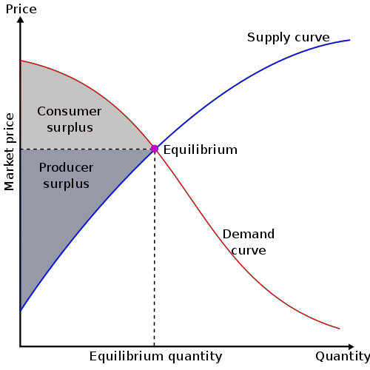Supply and demand curves, showing the different amounts of goods that will be supplied or demanded at different prices, do not reflect anything about the human condition. It is the theory that a market is in equilibrium, with both allocative and productive efficiency achieved, where the supply and demand curves intersect. At this point, in theory, everything that is being produced is being bought and total surplus is at a maximum. Total surplus, the sum of consumer surplus and producer surplus, represents how
Figure 2: Consumer and producer surplus
both the consumer and the producer benefit from the trade at the “market equilibrium price”: the consumer, who would have been willing to buy less of the product for a higher price, in fact receives more of the product and for a lower price; while the producer, who would have been willing to sell less of the product for a lower price, is in fact able to sell more of the product

and for a higher price.

However, traditional models of the unrestricted market system have many defects and have provoked many criticisms. Chief among them is the fact that items may have either positive or negative externalities (effects upon people who did not directly purchase the item), neither of which generally will be reflected in the product’s price. For example, treatment of a person with a contagious disease positively benefits other members of the society: they will not catch the disease. On the other hand, the production of a certain good might result in pollution, a negative externality. The damage to the environment done by pollution generally is not factored into an item’s cost, just as people do not pay for the benefit they receive from another person’s healthcare treatment. And thus, the price of products often does not reflect their true impact on society and the environment.
Certain proposed measures to deal with negative externalities, such as a “carbon tax” in the case of pollution, certainly would help encourage businesses to consider more carefully the effects of their production methods on others besides simply themselves and their customers. In a perfect world, everyone would always keep the needs of others in mind anyway, without having to impose such measures. However, we unfortunately do not live in such a world. When negative externalities exist, measures should be introduced so that the market more accurately represents the cost (or benefit) to society of the good or service produced.

Allocation of Goods, Efficiency, and Competition:

Francis Ysidro Edgeworth, an Irish economist, developed a way to envision the allocation of two goods between two people: an Edgeworth box. (This can be generalized to represent the allocation of multiple goods between multiple members of a society.) An Edgeworth box represents the many possible ways to divide the two goods between the two people. A point in

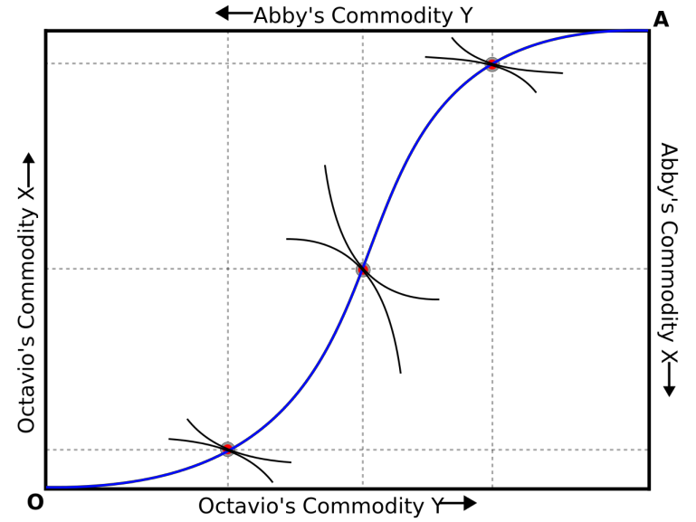the box is said to be “Pareto optimal” or “Pareto efficient” if there is no way to re- distribute the two goods such that both people benefit. However, such an “optimal” or “efficient” system is not guaranteed to be a just distribution. The extreme example of this is that if one person has all of the goods and the other person has nothing, there is no way that the goods can be re-distributed between
Figure 3: All points on the blue curve, at which Abby and Octavio’s indifference curves (curves representing combinations of goods that yield the same amount of utility, or satisfaction) are tangent, represent Pareto optimal points.
the two people without negatively affecting the person who has everything.

Within a given Edgeworth box, there are infinitely many points that are “Pareto optimal”, depending on how much each person values each of the goods. Some of those points may, in fact, be considered to be “just” distributions of the two goods between the two persons. The Second Fundamental Theorem of Welfare Economics states that any given “Pareto optimal” point may be obtained through an initial re-distribution of wealth and then letting the market take over. This may seem to be an endorsement of a free market with no regulation. However, the proof of this theorem only holds under certain conditions: (1) that every asset in the society has a price and every member of society has full information about each of these assets and (2) that the market is perfectly competitive. In general, these conditions are not met in the real world. Truly perfect competition, in which a large number of companies sell exactly identical products, cannot be achieved. If two seemingly-identical goods are sold at different stores, they are not actually identical because the stores are different: it may be easier to get to one than to the other.

Additionally, it is very difficult to create prices that accurately represent every single asset and their externalities. In what is now known as the Greenwald-Stiglitz theorem, Joseph Stiglitz, a Nobel-Prize winning economist, claimed that market systems are, in fact, always Pareto inefficient, because there is always imperfect information and it is never possible to put a price tag on all externalities produced. Stiglitz envisioned a system where markets and governments balanced each other to create a more just and equal society.
Different levels of competition within markets are, according to economic theory, differently suited to promoting the well-being of society, as measured by total surplus, the sum of consumer surplus and producer surplus. Consumer surplus is the difference between the maximum amount that consumers are willing to pay and what they actually pay, while producer surplus is the difference between the minimum price that producers are willing to accept and the actual price. Within market systems, the level of competition that produces the greatest total surplus is perfect competition. This is a system in which three conditions are satisfied: (1) that any firm is free to enter or exit the market, (2) that all firms sell exactly identical goods, and (3) that the firms are price-taking. This third condition means that firms cannot raise their prices for their products above the current market price at all. If they did so, they would not be able to sell anything, because potential customers could buy that identical product from any other seller.
However, as was mentioned earlier, in reality markets are never truly perfectly competitive.

The other levels of competition: monopolistic competition (the prevailing form in most markets), oligopoly, and monopoly all involve deadweight loss, even when the market is at its equilibrium. This means that there is a loss of certain parts of the surplus that would be produced if the market were perfectly competitive. This occurs even though the market has achieved allocative and productive efficiency – consumers are purchasing all the goods that are

being produced (allocative efficiency) and the cost of producing one additional unit of the good is equal to the revenue that would be gained from producing that additional unit of the good (productive efficiency).
A free market system on its own does not guarantee that the markets within it will be perfectly competitive. In fact, unregulated, they tend towards monopoly or oligopolies, which are the worst outcomes possible. The additional surplus that the producer gains is smaller than the amount of the surplus that the consumer will lose, so there is a net negative effect on society as a whole.
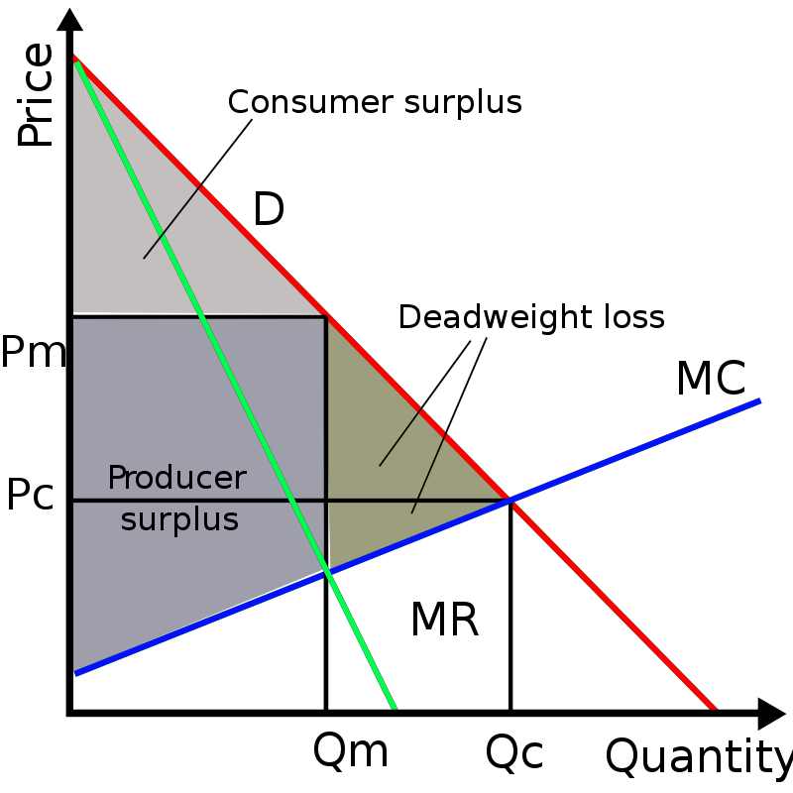Unregulated markets tend toward monopoly for various reasons, chief among them the profit motive. Large companies can produce more cheaply (through buying raw materials in bulk, etc.), up to a certain point, when too much bureaucracy can actually reduce efficiency (things need to go through a long chain of command to be approved, etc.) Monopolies can also raise their prices higher, since they control the market for the given good that they are producing. Pope John Paul II therefore, in his encyclical
Figure 4: Consumer surplus, producer surplus, and deadweight loss under monopoly.
Centesimus Annus, declared, “The State has the further right to intervene when particular monopolies create delays or obstacles to
development” (48). It is not wrong for monopolies to earn expanded profits due to the market not being perfectly competitive, but it is wrong, as John Paul II pointed out, for
monopolies to earn their profits at the expense of the weaker members of society.

All of the above points to several conclusions. Markets in and of themselves will never be perfect, as human beings are not perfect. They will always have the potential for failure.
They must be guided and rooted in something deeper, an understanding of the true needs of society and a desire to serve others. Like everything in a Christian’s life, participation in the market must be for the purpose of serving others first and foremost, rather than first and foremost for profit. Yes, this will require some difficult decisions. But these are very necessary ones – as has been stated before, we must be committed to serving the common good of the society, respecting the dignity of all persons, including the weak and vulnerable. Markets provide a very useful measure of what the people of a society might desire: companies can measure the success of products that they develop by measuring the amount that people buy of it at certain prices, helping producers to determine what they should be producing. However, companies must not, of course, base their production decisions solely on what society wants: for example, there is demand for pornography, but this is not something that will truly benefit society. It could bring temporary pleasure to some and profit to others, but it will never bring true benefit or lasting happiness to anyone, is rooted in debased desires and exploitation and objectification of others.
All of these negative aspects wound society, as was stated earlier in this paper in the explanation of the principle of solidarity. Thus, any business that is not rooted in a genuine desire to serve others and is not intended to lift people heavenward can be said to produce negative externalities that are not reflected in the price of such a product.

Obligations of Producers, Workers, and Governments:

Markets can certainly thus set guidelines for the production of goods, helping producers make production decisions, but these decisions must not be made solely by considering the state of the market, as in the example just mentioned. As Pope John Paul II wrote,

“It would appear that, on the level of individual nations and of international relations, the free market is the most efficient instrument for utilizing resources and effectively responding to needs. But this is true only for those needs which are ‘solvent’, insofar as they are endowed with purchasing power, and for those resources which are ‘marketable’, insofar as they are capable of obtaining a satisfactory price.”
(Centesimus Annus 34)

He goes on to remind us that “man’s work and his very being” must not be “reduced to the level of a mere commodity” (34) – again, externalities must be considered and producers must be certain not to exploit or take advantage of their resources, both human and environmental.
Laborers, on the other hand, also have certain responsibilities. They must do their work conscientiously and well, “for the greater glory of God”, but they have a duty to themselves and their fellow workers to stand up for themselves and their fellow workers if need be. If the workers, with perhaps the help of a union or trade association they might belong to, cannot resolve the disagreement with the producer, perhaps then it would be time for the State to step in. But these “must be as brief as possible, so as to avoid removing permanently from society and business systems the functions which are properly theirs” (Centesimus Annus 48).
Pope John Paul II criticized the “welfare state”, or as he referred to it, the “social assistance state”, on the basis that such a system oversteps the bounds and functions proper to the state, introduces unneeded bureaucracy, and tends to treat people in an impersonal manner: “By intervening directly and depriving society of its responsibility, the Social Assistance State leads to a loss of human energies and an inordinate increase of public agencies, which are dominated more by bureaucratic ways of thinking than by concern for serving their clients…” (Centesimus Annus 48). Emphasizing again the Church’s commitment to the principle of subsidiarity, he
implores that needs be met, wherever possible, by “people who are closest to them and who act as neighbours to those in need” (48). In this way, people can be served in a more personal way.

What might this look like when put into practice? Perhaps welfare policies could be implemented on the state/province level or even on the local community level, rather than the national level. Local charitable work should be encouraged and supported as much as possible. It must be noted, however, that the principle of subsidiarity does not mean that communities with more resources may simply serve the needs of their own members and ignore other communities that do not have as many resources. The principle of solidarity must also be respected. Here, what is called for is cooperation – communities with more resources understanding and responding to the needs of their own members as well as supporting the needs of less-well-off communities, always keeping in mind the Church’s dedication to a preferential option for the poor and vulnerable. Ideally, this would be done voluntarily, and policies encouraging this should be promoted. If, in spite of this, certain communities do not receive the help they need from other communities and it is necessary for a higher-level government with more resources to step in, still any aid received from the higher government should be administered on the local level as much as possible. Needs vary from place to place and the local community ought to know the needs of its individual members and how best to meet those needs better than a higher- level government would.
A society based on the principles of Catholic social teaching must also keep in mind the grave importance of helping people to help themselves, in accordance with respect for human freedom and dignity. People should not have to depend forever on outside assistance, even if this is coming from a local community. For example, the unemployed should be helped to find new jobs, if possible. If their skills do not match with the skills currently needed in the economy, they should be trained so that they may develop skills that will allow them to provide for themselves and their families. Some such programs are already in place: for example, many

homeless shelters provide their guests assistance with resume preparation. Some teach basic computer skills. Many other local organizations provide assistance in these areas as well.
However, more such programs are needed to assist people and make sure that they have skills that match the skills currently in demand in the labor market so that they can obtain jobs that will allow them to meet their needs and the needs of their families. To achieve this end, it would be well to expand existing job training and vocational programs and ensure that they are accessible to those that need them most. Programs and services that help people to overcome addictions, mental illness, and other barriers to participating in the labor force are also invaluable in helping people to achieve self-sufficiency rather than having to rely permanently on social assistance.
Of course, it is certainly true that there are certain conditions under which adults are not able to participate in the labor force either temporarily or permanently, such as maternity /
paternity, chronic illness or disability (of oneself or one’s family members), severe mental illness, etc. In these cases, again the principle of subsidiarity in conjunction with the right of all human beings to live in dignity must be kept in mind when designing policies to meet these people’s needs. The unique personhood of each individual makes each case different.
Similar principles ought to be kept in mind in countries’ international dealings. As Pope John XXIII wrote in Mater et Magistra, “The solidarity which binds all men together as members of a common family makes it impossible for wealthy nations to look with indifference upon the hunger, misery and poverty of other nations whose citizens are unable to enjoy even elementary human rights” (157). He goes on to call on the nations of the world to aid each other in times of famine by giving of their surplus: “Justice and humanity demand that those countries which produce consumer goods, especially farm products, in excess of their own needs should come to the assistance of those other countries where large sections of the population are

suffering from want and hunger” (161). Pope John XXIII encouraged more-developed countries to allow international students into their universities and otherwise help members of less- developed countries to obtain knowledge, skills, and capital with which they could work toward the development of their home nations.

Wages and Property Rights:

Two more points expanding upon certain ideals mentioned earlier ought to be made before we conclude this paper. The first has to do with the idea of a living wage, implied by the principles of participation and respect for human dignity mentioned in the summary of the key tenets of Catholic social teaching. In fact, various popes have explicitly called for living wages for workers in their encyclicals. For example, Pope Leo XIII wrote, “Let the working man and the employer make free agreements, and in particular let them agree freely as to the wages; nevertheless, there underlies a dictate of natural justice more imperious and ancient than any bargain between man and man, namely, that wages ought not to be insufficient to support a frugal and well-behaved wage-earner” (Rerum Novarum 45). This is connected to the principle of the dignity of human life: workers ought to be able to support themselves and their dependents through the wages that they earn through responsible, diligent work. Of course, this implies that the workers have a duty to work conscientiously and to spend their wages wisely.
The popes, along with economists and many others, do however realize the effect that paying workers a higher wage could have upon businesses, especially small businesses. They note that the amount of a worker’s wage must take these factors into account as well:
“In determining the amount of the wage, the condition of a business and of the one carrying it on must also be taken into account; for it would be unjust to demand excessive wages which a business cannot stand without its ruin and consequent calamity to the workers. If, however, a business makes too little money, because of lack of energy or lack of initiative or because of

indifference to technical and economic progress, that must not be regarded a just reason for reducing the compensation of the workers. But if the business in question is not making enough money to pay the workers an equitable wage because it is being crushed by unjust burdens or forced to sell its product at less than a just price, those who are thus the cause of the injury are guilty of grave wrong, for they deprive workers of their just wage and force them under the pinch of necessity to accept a wage less than fair.”
(Quadragesimo Anno 72)

Any wage requirements must therefore take into consideration not only the local cost of living, but also the local cost of running a business, assuming that both workers and producers are attempting to use resources efficiently, sustainably, and productively. It must also be considered whether wage requirements would cause unemployment, especially in small businesses. Large businesses would generally make enough profit to be able to pay their workers just wages, although this may imply some sacrifice and decrease in salary for top-paid executives. Pope Pius XI’s quote above also implies that governments / society must not enact unjust burdens on businesses. In keeping with the principle of subsidiarity and the ideals of distributism, policies promoting and benefiting small businesses, the ones most likely to have to lay off workers according to the ups and downs of the business cycle, ought to be enacted.
The popes acknowledge that in some cases, it might not be possible for businesses to be able to pay their workers living wages, for at least a temporary time period. In this case, they call on workers’ unions and local communities and charities to help their members and for workers and employers to consider “whether the business can continue or the workers are to be cared for in some other way” (Quadragesimo Anno 73). John Ryan advocates co-operative production and co-operative distribution to enable workers to gain a share in capital in the companies in which they work and the stores in which they buy products. Through such ownership of capital, he suggests that workers could earn interest, helping supplement their

incomes in times when their employer, even if using resources efficiently and wisely and not taking an unjust share of the profits, could not afford to pay all employees a living wage.
Ryan notes that more widespread private ownership of capital and other property through co-operative enterprises would have other benefits, too:
“For the wage earner proprietorship in a co-operative concern is preferable to any other kind of capital ownership because of the training that it affords in business management and responsibility, in industrial democracy, and in the capacity to subordinate his immediate and selfish interests to his more remote and larger welfare. Co-operative ownership with which men work has advantages of its own over co-operative ownership of the stores from which they made their purchases, inasmuch as it increases their control over the conditions of employment, and gives them incentives to efficiency which results in a larger social product and a larger share thereof for themselves.”
(Ryan 424)

Such co-operative enterprises would also conform to the Catholic social teaching of the right to private property and the distributist ideal of ownership of capital and other property spread as widely as possible. Widespread ownership should also help to reduce the rampant inequality that is so widespread both within and between nations worldwide, as was noted in the introduction.
The considerations above remind us yet again of the duties of businesses both in regards to their employees and in regards to the societies within which they operate. It must always respect these and strive for the greater good of all of them. In doing so, its ultimate goal ought not to be simply to attain a good reputation for the sake of acquiring business contracts or other solely profit-based motives, as that would mean that businesses would only express care for their employees and/or communities when it was likely to prove convenient to themselves to do so.
Rather, a Catholic-Christian way of thinking requires a different approach, as Melé and Schlag describe in their summary of Christian humanism:

  - ts approach differs substantially from certain current business and management doctrines which see ethics or corporate responsibility exclusively as a means to avoid risks and to obtain profits. This is the case, for instance of the concept “Creating Shared Value” formulated by Michael Porter, which lacks consideration of the dignity of human beings and the intrinsic value of a responsible behavior. In contrast, Christian Humanism emphasizes both of these, without regarding profits as a motive to respect human dignity nor for ethical behavior.”
(Melé and Schlag 5)

Likewise, Pope John Paul II once wrote, “People lose sight of the fact that life in society has neither the market nor the State as its final purpose, since life itself has a unique value which the State and the market must serve” (Centesimus Annus 49). Businesses (and government) must, therefore, always keep this grave responsibility in mind and do their best to function for the good of their workers, their society, and their environment.
To this end, as has been stated before, what will be most greatly beneficial would be a restoration of society to morality and virtues. Indeed, as Michael Novak writes in his book Business as a Calling: Work and the Examined Life,
“Business has a vested interest in virtue. It cannot go forward with realism, courage, wisdom, honesty, and integrity without a highly motivated and virtuous work community. … In this and in many ways, business is dependent on the moral and cultural institutions of the free society: families especially, schools, and public civic life. A nation’s moral culture is even more fundamental than its physical ecology.”
(Novak 115) Only with a commitment to the cultivation of true morality and virtue will businesses,
governments, and individual members of society gain a solid foundation for a commitment to respect for human life even at its weakest and most vulnerable, justice, solidarity, sustainability and respect for creation, and all the other ideals that will make for a fairer and more equal society
– in short, when business acts in a truly positive manner. And as Lloyd Sandelands writes,

“[B]usiness is positive when it invites us to be as Christ; which is to be a person in joyful communion with the Father; and which … is to take part in a joyful solidarity of persons in the common good” (Sandelands 86-87). This should be what all businesses strive for, rather than merely to obtain the greatest profits possible.
In conclusion, we have discussed the ten basic principles of Catholic social teaching, as expressed in various papal encyclicals of the nineteenth and twentieth centuries, and what some of their implications are when engaging in economic activity. We have also briefly discussed various Catholic efforts to create societies that more closely conformed to the ideals expressed in the Church’s social teaching, especially distributism and the Catholic Worker Movement, and how they can serve as a model and inspiration for modern reforms. We then discussed some basic economic theories about the functioning of market systems and some ways in which they may fail. We have criticized the underlying views of both traditional socialism and traditional unrestricted capitalism that view society solely through a materialist point of view and have called for a more personalistic approach in economics and society, with greater subsidiarity and expanded private ownership of capital. Simultaneously, we have noted the need for regulation in the markets so that they are more oriented toward the common good. To this end, we have noted that society must turn back to morality and virtue for a solid foundation on which to attempt to reach these goals in a balanced manner; and we have noted some of the rights and duties of employees, businesses, government, and society. We have attempted to provide some examples of practices and policies that would be in keeping with the principles of Catholic social teaching and that would help create a more just and equal society.

Bibliography:

Byron, William J. “The 10 Building Blocks of Catholic Social Teaching.” America, vol. 179, no.

13, Oct. 1998, pp. 9–12. EBSCOhost.

Crosby, John F. Personalist Papers. The Catholic University of America Press, 2004. Dalio, Ray. Interview with Bill Whitaker. CBSNews, 7 April 2019,
https://www.cbsnews.com/news/ray-dalio-capitalism-needs-reform-wealth-inequality-is- a-national-emergency-60-minutes/
John XXIII. “Mater et Magistra.” The Holy See, 15 May 1961, http://w2.vatican.va/content/john- xxiii/en/encyclicals/documents/hf_j-xxiii_enc_15051961_mater.html.
John Paul II. “Centesimus Annus.” The Holy See, 1 May 1991, http://w2.vatican.va/content/john- paul-ii/en/encyclicals/documents/hf_jp-ii_enc_01051991_centesimus-annus.html.
Leo XIII. “Rerum Novarum.” The Holy See, 15 May 1891, http://w2.vatican.va/content/leo- xiii/en/encyclicals/documents/hf_l-xiii_enc_15051891_rerum-novarum.html.
Melé, Domènec and Martin Schlag. “Christian Humanism in Economics and Business.” Humanism in Economics and Business, edited by Domènec Melé and Martin Schlag, Springer Netherlands, 2015, pp. 1-10.
Novak, Michael. Business as a Calling: Work and the Examined Life. The Free Press, 1996. Penty, Arthur J. “Distributism: A Manifesto.” Distributist Perspectives, edited by John Sharpe,
vol. 1, IHS Press, 2004, pp. 86-110.

Pius XI. “Quadragesimo Anno.” The Holy See, 15 May 1931, http://w2.vatican.va/content/pius- xi/en/encyclicals/documents/hf_p-xi_enc_19310515_quadragesimo-anno.html.
Ryan, John A. Distributive Justice. Arno Press, 1978.

Sandelands, Lloyd. Love First: Toward a Christian Humanism. Hamilton Books, 2017.

Schmemann, Alexander. For the Life of the World: Sacraments and Orthodoxy. 2nd ed., St.

Vladimir's Seminary Press, 1973.

Stiglitz, Joseph E. The Price of Inequality: How Today’s Divided Society Endangers Our Future.

Norton, 2013.

“Toward Reforming the International Financial and Monetary Systems in the Context of Global Public Authority.” Pontifical Council for Justice and Peace, 24 Oct. 2011, http://www.vatican.va/roman_curia/pontifical_councils/justpeace/documents/rc_pc_justp eace_doc_20111024_nota_en.html.
UNDP. Human Development Report 2016: Human Development for Everyone. UN, New York, 2017, https://doi.org/10.18356/b6186701-en.
Zwick, Mark and Louise. The Catholic Worker Movement: Intellectual and Spiritual Origins.

Paulist Press, 2005.

