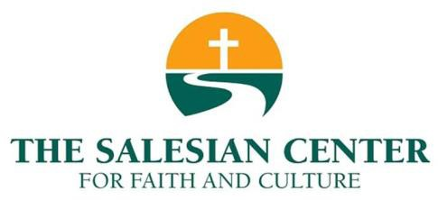
“DeSales Book Club”
Reading list

Decisive: How to Make Better Choices in Life and Work Hardcover by Chip Heath, (March 26, 2013), 336 pages

It's Not Supposed to Be This Way: Finding Unexpected Strength When Disappointments Leave You Shattered by Lysa TerKeurst (November 13, 2018) 256 pages

Lord of the World by Robert Hugh Benson (1907).

Mathematics Through the Eyes of Faith by Russell Howell & James Bradley, 288 pages

Notes on the Death of Culture: Essays on Spectacle and Society, by Mario Vargas Llosa (Farrar, Strauss & Giroux, 2015), 240 pages.

Taking My Life Back: My Story of Faith, Determination, and Surviving the Boston Marathon Bombing by Rebekah Gregory, 240 pages

The Global Sexual Revolution: Destruction of Freedom in the Name of Freedom
Paperback – December 2, 2015 by Gabriele Kuby, 302 pages

The Mathematics of the Gods and the Algorithms of Men: A Cultural History by Paolo Zellini & Erica Segre, translated by Carnell Simon, 240 pages

The Opposite of Loneliness: Essays and Stories, by Marina Keegan (Scribner, April 2015), 256 pages.
The Power and the Glory by Graham Greene (1940)

The Power of Moments: Why Certain Experiences Have Extraordinary Impact
by Chip Heath and Dan Heath, 320 pages

The Way of the Warrior: An Ancient Path to Inner Peace Hardcover by Erwin Raphael McManus (February 26, 2019) 256 pages

Truths We Confess: A Systematic Exposition of the Westminster Confession of Faith By: R.C. Sproul (2019)

Unbroken: A World War II Story of Survival, Resilience, and Redemption by Laura Hillenbrand, 528 pages

Vast Universe: Extraterrestrials and Christian Revelation by: Thomas F. O'Meara

Where You Go Is Not Who You’ll Be: An Antidote to the College Admissions Mania, by Frank Bruni (Grand Central Publishing, March 2015), 224 pages.

